# Introduction to Mapping with Carto

**Learning Objectives**

We are going to explore how to use Carto to manage and map geospatial data. Today, we will look at how to load and visualize datasets that we upload from shapefiles, the most common file format for vector spatial data. (Other file formats supported by CARTO include *CSV, KML, GeoJSON*, and *SVG*).

# TO DO BEFORE LAB (at least 3 days before)

We are going to use Carto as one of the web mapping tools in this course. Carto offers a student bundle that provides free access to their platform as a student (note this is not a limited 14 day or 30-day trial - it is the full package until you graduate.) It comes in a bundle with other developer tools and requires **first signing up for a Github student account.**

You should have set up your Github Student Developer Account before this lab. **If you have not done so before the lab session, go to the next step and see the Note section.** You will still need to set up the Developer Account later on by following the instructions in the “Github Student Developer Pack Instructions” handout in this week's lab folder.

# Getting Started in Lab (10 min)

1. Go to carto.com and click “Login” in the upper right. In the login dialog, **select the “Log in with GitHub”** button at the bottom to sign in with your GitHub credentials. Make sure to **use the account that you created in anticipation of this lab**, which is attached to your Berkeley email address, and verified as part of the Student Developer Pack.

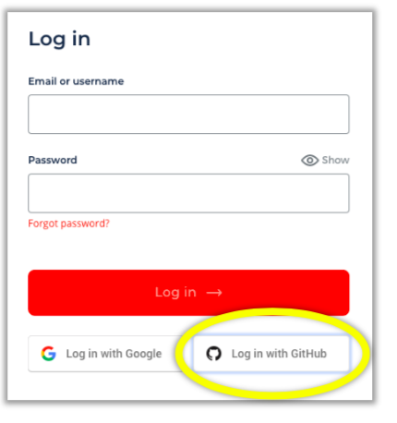

**Note:** If you are having difficulties with GitHub or did not make a GitHub account, please return to Carto’s home page and create a Free Trial account (Select “Free Trial”) for the purposes of the lab session.

1. Please download the file for this lab from bCourses. It includes one zip file named “**Land Use**”. It contains a set of files that are collectively called a “shapefile,” which store spatial data. Make sure **not** to unzip these folders when you download them.

A shapefile is made up of multiple files with the same name but different extensions (e.g., “my_shapefile.shp”, “my_shapefile.dbf”, and “my_shapefile.prj). Each of these files stores a different type of information (e.g., the geometry: *.shp; data table: *.dbf; and projection information: *.prj.)

# Loading Data into Carto (15 min)

1. Once you sign in, you will be in your Carto “dashboard.” Here you can see existing maps and data you have already loaded. You probably don’t have any maps or data yet.
2. Next, you want to upload the Land Use shapefile you downloaded from bCourses so you can use them to make a new map.
   * Click the “New Dataset” button in the lower-right.
   * On the next page, select “Upload” from the ribbon menu.
   * You can then use the “Browse” button to find your shapefile on your computer, or just drag it into the “Drag & drop” area.
   * Then click “Upload Dataset” in the bottom left to complete the upload.
   * To make sure you upload all of the files that make the shapefile, just **upload the zip file** with all of them inside.

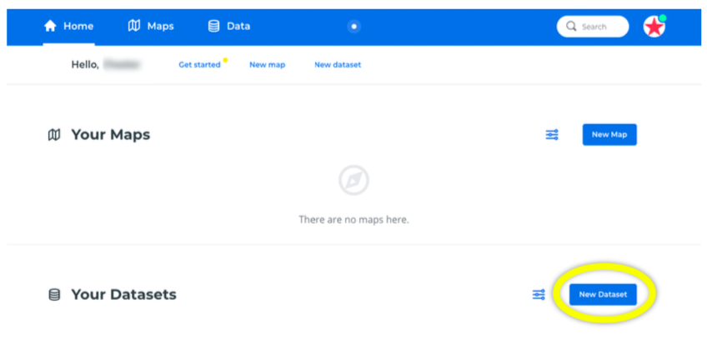

After you upload a dataset you will see a preview of its attribute table. To get back to your dashboard, click the circular Carto icon in the upper right corner.

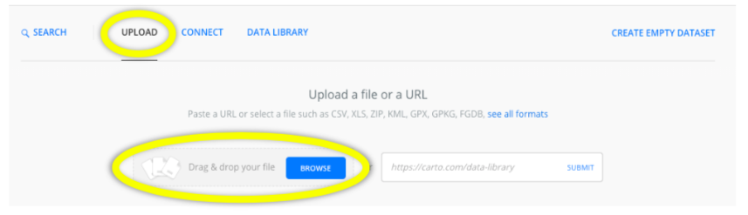

1. Go back to your dashboard and look under “Data” and “Your Datasets” (from the ribbon menus). You should see the dataset you just uploaded.

**Notes**:

a. Sometimes your dataset may not have the most useful names. If that’s the case, you can rename a dataset by clicking the ellipsis button (three dots) on the right side when you hover over it. Click “Edit name & description” in the popup menu. Here you can change the dataset name, add descriptive text, a source, attribution and license information, and tags that might help you or others more easily find the dataset later.   
  
b. Carto prefers names with all lowercase letters and no spaces, so it may automatically adjust your custom name to fit these parameters. **Note:** By default, **all the data you load into Carto will be publicly accessible.** This can be handy for sharing data with a broad audience, but you will want to **be careful not to publicly share personally identifiable or other sensitive data.**

# Creating your first map (5 mins)

1. To preview the “land_use” dataset, click on its name in the dashboard. This will open a table showing each attribute as a column and each data record as a row. Both of our datasets are of the polygon type, so the “geometry” column lists “Polygon” for all records. Behind the scenes, the coordinates for these polygons are stored as objects in this table, just like the other attributes.

You can see how these polygons look on a map by clicking “**Preview**” at the bottom right of your window. Once you’ve observed the preview, click on the “**Create Map**” button.

1. The navigation panel on the left side shows the layers that are displayed on your map. Initially, you have two layers: a base layer (“Voyager” is the default, but you can choose another if you’d like) and the land_use dataset.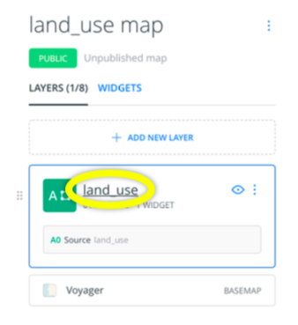

# Editing your map (10 min)

1. At the top of the layer options dialog there are five tabs: “Data,” “Analysis,” “Style,” “Pop-up,” and “Legend.” Let’s click on the “**Data**” tab. It allows us to add widgets alongside our map that summarize attributes. Each of the attributes included in the land_use dataset is listed in the side panel. To add one, click on the checkbox to its left. Can you add a widget that summarizes the number of polygons within each land use classification by selecting the **landuse** attribute and use (note that the widget contains the list of categories under the landuse attribute. Note also that some land use designations are grouped by CARTO under ‘Other’).

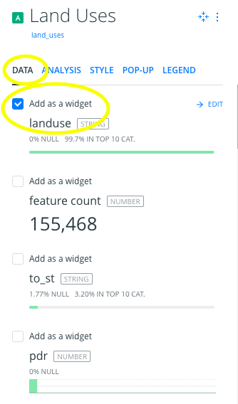

Once you have selected a widget, click on “back” and then select “Layer”. Now click on the layer “land_use” so you can customize it.

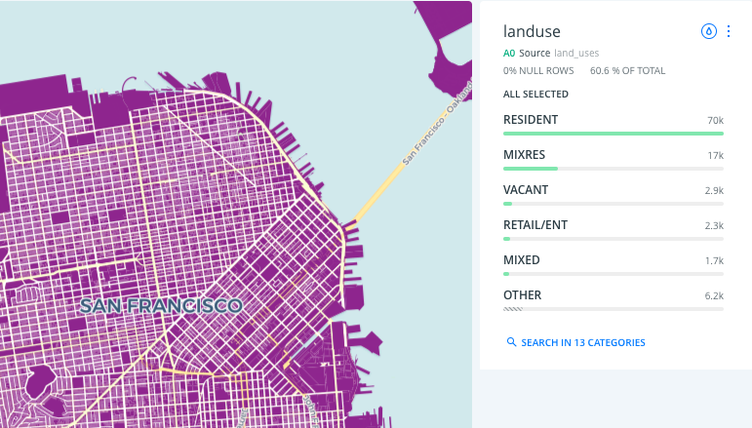

It would be helpful to distinguish between land uses by making them different colors. To do this, click on the **“Style”** tab in the layer options. Right now, all the polygons (parcels) are being drawn in the same “Solid” color. Instead, you want to color **“By value.”** Select this option, then the attribute ‘landuse’ from which we want to get the categorical values (e.g., Residential, Retail, Open Space, etc.).

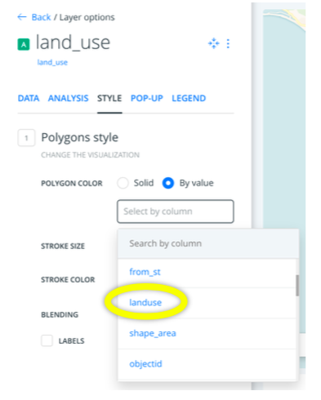

By default, it will apply a set of colors ranging across the whole rainbow. This type of color set is good for displayed categorical data because it’s easy to differentiate between neighboring polygons.

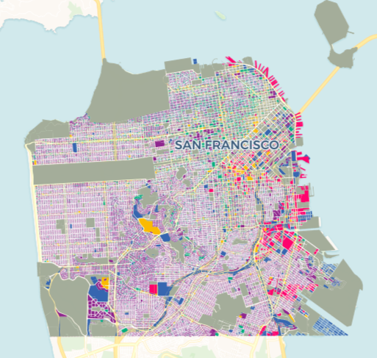

Notes:

1. You may want to change the colors to follow [land use color-coding standards](https://www.planning.org/media/document/9153095/). Under ‘Polygon Color’, in the Style menu, select again the layer ‘landuse’ and then select ‘Custom color set.’ Now you will see a pop-up window with a list of all land uses and the color is currently assigned to each. Click on one category, and change the color. Repeat the process for all categories so they follow the APA Land Based Classification Standards.
2. If we were mapping data along a numeric scale we might instead want to use a color set that ranges from light-to-dark within the same color.

Now our map shows each polygon in a color corresponding to its land use. Because there are so many small polygons, you may need to zoom in before they draw properly on the map.

**To Do On Your Own**

You might also want your widget to coordinate with the map by using the same colors. To do this, click on the tiny droplet icon (“Apply Auto Style”) in the upper-right corner of the widget. This will transfer the colors onto the widget bars.

A very cool thing about Carto is that its maps and widgets are dynamic and interactive. You can zoom and pan on the map to get a closer look at your data. When you do this, the widget will automatically update to reflect just the part of the map you are viewing. If you want, you can turn this off under the widget options, so the widget always reflects the whole dataset. Usually, however, this is a helpful analytical tool; it’s essentially a spatial filter for the summaries displayed in your widget.

You can also use the widget to filter the data on the map. Click on one of the land uses. The map will now only show polygons associated with that land use. Click “All” in the upper-right of the widget to get all your land uses back.